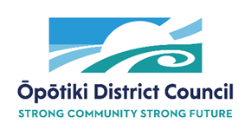

Te Tāhuhu o Te Rangi Panel Art Features - Proposal Application Form

Artist name: ________________________________________________________________

Email contact: _______________________________________________________________

Phone contact:_______________________________________________________________

What is your connection to the Ōpōtiki District:____________________________________

Art concept proposal (including materials, size and subject matter): ____________________
___________________________________________________________________________

Proposed weight (approx.):_____________________________________________________

Sketch/Marquette (can be submitted separately):

Quote (please itemize):________________________________________________________

___________________________________________________________________________

Previous experience (can be submitted as a résumé/separate document and include photos):

___________________________________________________________________________

In the event my proposal is not selected for permanent display, I wish to discuss producing a piece of art for exhibition (please tick):

Yes: No:

Any other comments/ information:______________________________________________

Please ensure this form is submitted by 4pm, Tuesday 9 March 2021.

This form can be submitted by email to info@odc.govt.nz or delivered by hand to Council offices at 108 St Johns Street, Ōpōtiki (open 8am-5pm Monday to Friday).

Please note this is an application form only and completion and submission of this document does not guarantee acceptance of proposal.

